SECTION 4: HOW DID THE COLD WAR DEVELOP? 1943-56

The widening gulf between the Allies

When the Second World War began in 1939, Britain faced Germany with few allies. Following the German invasion of the Soviet Union in June 1941, Britain and the Soviet Union formed an alliance against Hitler. This alliance was extended when Hitler declared war on the USA after Japan’s attack on the USA in December 1941. This brought Britain, the Soviet Union and the USA together as allies. These three powers together became known as the Grand Alliance, and their leaders – Churchill (Great Britain), Roosevelt (USA) and Stalin (Soviet Union) became known as the ‘Big Three’.

However, this alliance did not mean close friendship and harmony. There was constant tension throughout the war. There had been distrust between these three countries since the Bolshevik Revolution in 1917. Moreover, Stalin always pointed to the fact that the Western Allies had intervened in the Russian Civil War in 1918-9. Furthermore, he suspected that they had encouraged Hitler in the 1930s and sought to use him as a bulwark against communism. He was aware of the intrigue that Britain and France had been a party to in 1939 when they were trying to create defensive alliances.

Stalin’s view about future decisions was also influenced by the two German invasions of 1914 and 1941. He wanted to build a buffer zone against possible future German attacks and this idea of a buffer zone conflicted with the ideas of Churchill, who did not wish to see communism spread into Western Europe.

In addition, the distrust was compounded by Stalin’s suspicion that the Allies deliberately delayed the opening of the Second Front in France, even after agreements were made about the date. He believed that the USA and Britain had wanted the Soviet Union to destroy itself fighting Germany on its own. He also felt that any weakening of the Soviet Union would leave Britain and the USA in a stronger position than the Soviet Union. Millions of Soviet citizens were killed in the war (by 1945, approximately 25m) and Stalin wanted to avoid a recurrence of this.

The mistrust between the wartime allies was not wholly on Stalin’s part. The two western allies still believed that communism’s aim was to impose that belief-system on the whole world. For many people in the west, communism was a loathsome philosophy and capitalism had to be protected at all costs. Furthermore, Britain and the USA felt that the Soviet Union was being selfish because Stalin did not declare war on Japan in 1941. The USA had supplied huge amounts of war materiel to the Soviet Union and the latter was only fighting a war on one front. The decision to attack Japan only after the defeat of Germany confirmed Churchill’s opinion of Stalin.

Checkpoint: Reasons for mistrust

Stalin | The West

The Tehran Conference, November- December 1943

The conference was given its own codename –‘Eureka’. Roosevelt hoped that this conference would cement close relations between the leaders. This was the first meeting of the ‘Big Three’ and the main discussion was focused on opening a second front in Western Europe. The central aim of the conference was to plan the final strategy for the war against Nazi Germany and its allies

The photograph below shows Stalin, Roosevelt and Churchill at the Tehran Conference, December 1943.

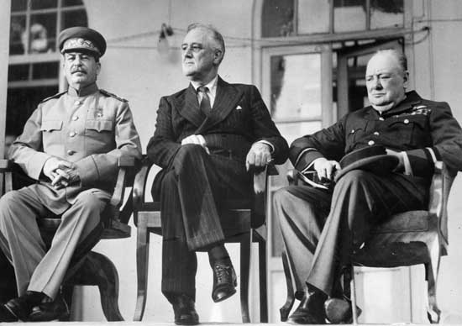

Decisions reached at Tehran:

- It was agreed that Britain and the USA would open up a second front by invading France in May 1944. The codename given to this invasion was Operation Overlord. There would an operation against southern France.

- The Soviet Union would simultaneously mount an offensive in the East against Germany.

- It was agreed that as much help would be given to partisan forces in Yugoslavia who were fighting Hitler.

- The Soviet Union would declare war on Japan once Germany was defeated.

- A United Nations organisation was to be set up after the war.

- Stalin was promised the lands that the Soviet Union had lost to Poland in 1920 and as a result of this Poland’s borders with Germany would move to the rivers Oder and Neisse.

Churchill did not really want the Second Front to be in the north of France. He wanted an assault from the southern part of the Mediterranean but he was overruled. Roosevelt felt that Churchill was only protecting the British Empire and he was keen to see the end of empires when the fighting eventually ceased. Roosevelt, Churchill, and Stalin agreed that the Axis powers would face unconditional terms of surrender, and that once defeated, the nations in league with the Axis powers would be divided into territories to be controlled by the USSR, the U.S., and the UK. However, no firm decisions were made.

Roosevelt was prepared to believe Stalin's promises that he would permit free elections in any countries that the Soviet Union liberated because Stalin said he was prepared to declare war on Japan and to join the UNO.

The Yalta Conference, February 1945

By early 1945, Stalin’s army had reached the German border and was ready for the final onslaught. Stalin’s army now totalled 12 million and this outnumbered the forces under Eisenhower (4 million). Roosevelt, Churchill and Stalin met at Yalta in the southern Soviet Union to plan the end of the Second World War. Decisions about the fate of Germany, its Allies and those territories it had absorbed had to be made. Some of the Teheran decisions were confirmed. Roosevelt appeared rather tired and weak at the conference and afterwards some observers accused him of giving in to Stalin’s demands.

A British cartoon showing the Big Three at Yalta helping the world to recover from the war.

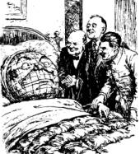

Differences between the Big Three emerged. Churchill was becoming convinced that Soviet troops would remain in the countries they liberated from German occupation. Churchill’s distrust was evident in his letters to Roosevelt when he said that Stalin was a threat to the free world. Nevertheless, both Churchill and Roosevelt needed Stalin's support in case it was necessary to invade Japan.

What decisions were made at Yalta?

Germany

The Allies eventually decided to divide Germany into four zones; each one would be occupied by one of the four allies. Stalin agreed to accept France as one of the powers – this was after much persuasion by Churchill. It was also decided that Berlin would be divided into four sectors. (Austria and Vienna were to be divided in a similar way.) In addition, it was agreed that Nazi war criminals would be tried in an international court of justice.

However, no agreement could be reached about reparations. Stalin was keen to cripple Germany’s so that it could never become a military power and Churchill did not want any punishment to bee too severe – as had happened in the peace settlement of 1919. However, a figure of $20 billion dollars was put forward.

Poland

Poland would be given land in the west, which would be taken from Germany and would lose land to the USSR. Stalin saw this acquisition of land as creating his buffer zone. He did agree that some members of the Polish government in exile (the London Poles) would be allowed to join the Polish government that he had set up (the Lublin Poles). Free elections would be held.

The other key decisions taken at Yalta clearly indicated the rising tensions and the way in which Stalin sought to increase the power and influence of the Soviet Union. He promised to allow free elections in the countries of Eastern Europe which had been occupied by the Soviet army. However, he had no intention of doing so and hoped to secure control of large areas of land. Roosevelt was happy to put up with Stalin’s actions and accept his claims because it was clear at this time that the war against Japan could go on for some time. Both the USA and Britain needed the assistance of Soviet intervention. Stalin saw an attack against Japan as another way of acquiring more territory.

The Big Three agreed that a conference at San Francisco in April of 1945 should formulate plans for a new world body – to be called the United Nations. Its aim would be to promote and keep peace. Roosevelt saw Stalin’s acceptance of this body as crucial and thought that this was a successful outcome of Yalta. It should also be noted that by the time of the Yalta Conference, Britain was clearly the third ally and some way behind the other two in the Grand Alliance.

The Potsdam Conference, July–August 1945

After Yalta, it soon became evident that Stalin was not about to adhere to the promises he had made. By July Soviet forces had occupied most of Eastern Europe: Finland, Estonia, Latvia, Lithuania, Hungary, Bulgaria, Romania, Czechoslovakia and Poland. In addition, Soviet forces were occupying parts of Germany and Austria. Wherever possible, Stalin and his Soviet forces resisted democracy and tried to ensure that new governments would be loyal to the Soviet Union.

However, when President Roosevelt died on 12 April, relations between the USA and the Soviet Union became more strained. He was succeeded by Harry Truman who took a much tougher line with Stalin. When Truman became aware of Stalin’s anti-democratic actions in Poland, a message condemning the actions was sent to Stalin. So, by April colder relations between the two countries were already evident.

The Potsdam conference was the last of the conferences between the leaders of the allies during the Second World War. During the conference, Churchill was replaced by Clement Attlee, who had become Britain’s new Prime Minister following the July general election.

On 16 July the USA had tested its atomic bomb, which meant that Truman no longer needed to rely upon the Soviet Union in the war against Japan. The USA did not wish to share the technology which had created the atomic bomb and Stalin saw this as a clear threat to the Soviet Union.

What was decided at Potsdam?

Germany

Ideally, Stalin wanted the permanent partition of Germany, but Britain and the USA were able to resist this.

Germany was divided into four zones. Each zone would be occupied by one of the four Allies, Great Britain, France, the USA and the USSR. Berlin was divided into four sectors. Germany was to be de-militarised. All German naval and merchant ships were to be given to the Allies.

The Nazi Party would be dissolved. War criminals would be tried and punished. Nazis were removed from important positions and leading Nazis were to be put on trial for war crime. These trials were held in Nuremberg during 1946.

There would be free elections in Germany, freedom of speech and a free press.
Germans living in Eastern Europe would be transferred into Germany.

Germany would pay reparations for the damage caused by the war. Most of this would go to the USSR, either in money or goods. Stalin was desperate to re-build the damaged Soviet economy. It was agreed that Stalin could take machinery from the Soviet occupied zone and would be allowed some machinery from the western zones (the Soviet zone was primarily agricultural).

Poland

An extract from a note Stalin sent to Churchill in April 1945 about Poland.

Poland has borders with the Soviet Union but does not have any with Great Britain and the USA. I do not know whether a democratic government has been established in Greece or whether the Belgian government is democratic. The Soviet Union was not consulted when these governments were being formed. We did not claim the right to interfere in those matters, because we realise how important Belgium and Greece are to the security of Great Britain.

Stalin viewed the issue of Poland as crucial to the security of the Soviet Union. It was to be the means whereby a buffer zone would be created. It was agreed that the Polish frontier was to be moved westwards to the rivers Oder and Neisse.

One of the most important decisions at Potsdam was the agreement of the Allies to take part in the United Nations. The UN had emerged from decisions made at meetings in Moscow, Teheran, Washington and finally San Francisco.

Despite the progress made about Germany and Poland, there were also many disagreements at Potsdam. President Truman tried to force the USSR to allow free elections in the countries of Eastern Europe, which had been occupied after the end of the war. Stalin pretended to be very angry about not being told about the US development of the atomic bomb. (Stalin’s agents in the USA had kept him informed of the whole bomb project.)

Thus the Grand Alliance began to fracture and with the defeat of Hitler in 1945, the cement which had kept the Allies together began to erode. This was the beginning of the ‘Cold War’. During 1945–46, Stalin’s policies showed that he did not trust the West and he kept control of those countries of Eastern Europe that had been liberated from Nazi rule. This led to Winston Churchill coining the term ‘Iron Curtain’.

For more information about the Yalta Conference, click here

For more information and photographs of the Potsdam Conference, click here

Checkpoint: Yalta and Potsdam

What decisions were reached at each conference?

Yalta | Potsdam

Explain three reasons why differences between East and West had emerged by Potsdam.

1

2

3

The development of the ‘Iron Curtain’

Churchill at the end of the ‘Iron Curtain’ speech

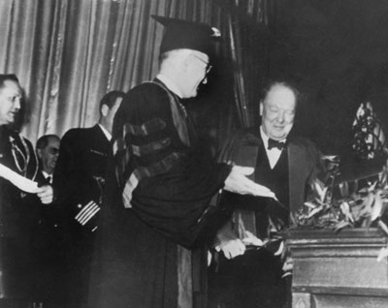

US reaction to Churchill’s ‘Iron Curtain’ speech

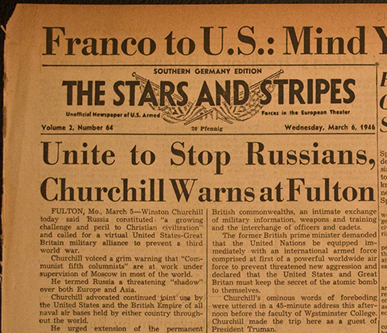

What was the Cold War?

The events of 1945 to 1949 led to what became known as the COLD WAR. This is the name used to describe the hostility between East and West which existed until the late 1980s. It was a war of propaganda and ideas, but there was very little actual fighting. A hot war is a conflict in which actual fighting takes place. A cold war is a war conducted against an enemy by every means without resorting to fighting. At first it was confined to Europe, but during the 1950s and 1960s it spread across world, as the USA and the Soviet Union sought to gain influence and control over as many countries as possible.

The ‘iron curtain’

A map showing the ‘iron curtain’
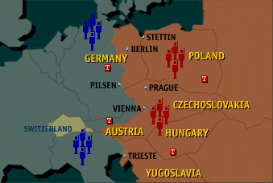

In February 1946, President Truman received a note about Soviet foreign policy from one of his advisers. The note stated that the Soviet Union would never co-operate with the USA and its long-term aim was to expand its empire. Thus the Soviet Union had to be contained – the policy of containment was born. In March of that year, Winston Churchill made a speech in Fulton, Missouri in 1946, during which he referred to the ‘iron curtain’. Churchill said the ‘iron curtain’ started at Stettin in the Baltic and went to Trieste in the Adriatic. Eventually, the ‘iron curtain’ became a thousand mile long armed border cutting off the Communist countries of Eastern Europe form the non-communist west.

Why did Stalin build the Iron Curtain?

He sought to set up a buffer zone of countries in Eastern Europe to protect the USSR against another invasion by Germany – he had seen two invasions in his own lifetime - 1914 and 1941. Above all, Stalin was determined to prevent this happening a third time and he wanted to make sure that Germany was kept weak, whereas the western Allies wanted Germany to be allowed to recover from the effects of the war. The western Allies were aware of the mistakes that had been at the Treaty of Versailles and did not want to see History repeat itself. In addition, Stalin was trying to prevent western influence reaching the west and refugees leaving the east for Western Europe. Refugees and displaced persons soon discovered that life in Soviet occupied areas was not always pleasant.

The remains of the Iron Curtain

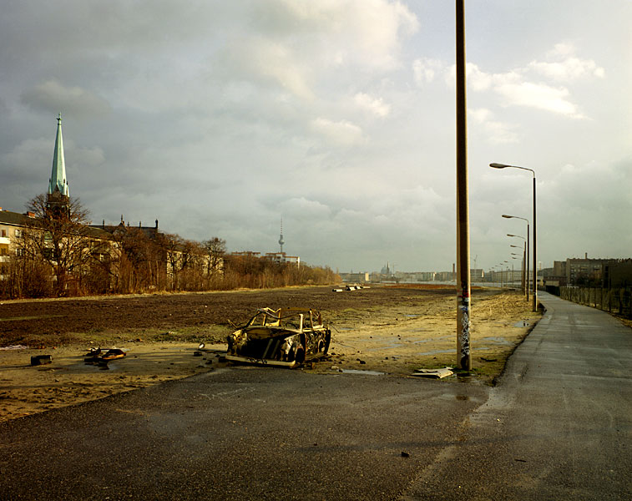

For more information and photographs of the Iron Curtain, click here

Soviet Control of Eastern Europe

How did Stalin secure control of Eastern Europe?

During the years 1945–48, all the countries which had been occupied by the Red Army at the end of the war were brought under Soviet control (Poland, Bulgaria, Romania, Hungary – the Baltic States of Estonia, Latvia and Lithuania had been absorbed in 1940 and then kept as part of the Soviet Union). In Czechoslovakia the leaders were simply murdered.

There was a distinct pattern to the Soviet takeover and control of the countries of Eastern Europe. Firstly, when countries were liberated from the Nazis, Stalin ensured that Soviet troops remained there. Then, Stalin ensured that any new governments were coalitions which meant that the Communist Party would have a say in the running of the country. Gradually, the Communist Party would infiltrate the key areas of government and security organisations. When elections took place, the Communist Party used any means necessary to discredit and frighten opponents. Such tactics enabled the Communist Party to take over the government of the country and then began to establish a one-party country – a communist state.
Stalin felt justified in establishing military rule in Hungary and Romania because these two countries which had fought on the Nazis’ side.

In Czechoslovakia, the Communist Party was the largest party in the coalition government by 1947. Stalin ordered Gottwald, the Communist leader to remove the non-communists in the government. In 1948, all communist opponents were removed. Masaryk, a leading opponent of Gottwald was found dead.

Having been a member of the coalition for two years, the Polish Communist Party fixed the elections of January 1947. The Polish Communist Party set up a government which took its orders from Stalin in Moscow.

In Bulgaria, the November elections of 1945 were fixed and the Communists won a majority of seats and in 1946, a one-party sate was established

The Hungarian Communist Party secured a large share of the vote and took over the government following the general election of August 1947. All other parties were then banned and the Communist leader, Rakosi, established a Stalinist regime.

By the November election of 1946, the Romanian Communist Party had won a huge majority and set up a government which then forced King Michael to abdicate in 1947. Soviet domination was thus complete.

Checkpoint: The Iron Curtain

Reasons for building the Iron Curtain | Effects on countries to the east

What was the Allied response to Soviet control of Eastern Europe?

The Truman Doctrine

The USA began to be concerned about the growth in popularity of the communist parties in France and Italy during the winter of 1946-47. In February 1947 the British government informed the USA that it could no longer afford to support the Greek government against Communist rebels. The USA had seen the spread of communism in the immediate aftermath of the war and now viewed the prospect of further countries becoming communist with great alarm. The US government stepped in with an offer of $400,000,000 to Greece and Turkey.

From President Truman’s speech to US Congress, 12 March 1947

At the present moment in world history nearly every nation must choose between alternative ways of life. The choice is often not a free one. One way of life is based upon the will of the majority, and is distinguished by free institutions, representative government, free elections, guarantees of individual liberty, freedom of speech and religion, and freedom from political oppression.
The second way of life is based upon the will of a minority forcibly imposed upon the majority. It relies upon terror and oppression, a controlled press and radio, fixed elections, and the suppression of personal freedom. I believe that it must be the policy of the United States to support free peoples who are resisting attempted subjugation by armed minorities or by outside pressures.

Why was the Truman Doctrine published?

By 1947, Truman and his advisers had become convinced that the Soviet Union was trying to spread communism through Eastern Europe and then to the west and beyond. Truman was frightened that if Greece was to become a communist country then this opened the gates to the rest of ‘free’ Europe. The ‘iron curtain’ had already cut Europe in two and it was felt that the USA should be seen to be resisting communism. While the Truman Doctrine did not actually mention the Soviet Union, it was obvious that it was intended as a warning to Stalin that Truman was not going to let him get away with any more attempts to take control of Europe. Truman was openly committing the USA to a policy of what became known as containment. Truman argued that the world was becoming divided into two armed camps – the capitalist camp, which he claimed was the free camp, and the communist, which was not. The USA would use its economic and military strength to protect the world from the threat of communism.

Truman also wanted to help the countries of Europe recover from the effects of the Second World War. He had seen the devastation, which the war had caused and he wanted the USA to play a part in recovery. Marshall Aid was announced at the same time. Truman also hoped that he might be able to persuade some of the countries of Eastern Europe to break away from Communism.

A German poster for the Marshall Plan; translated, the words read – ‘An open road for the Marshall Plan’

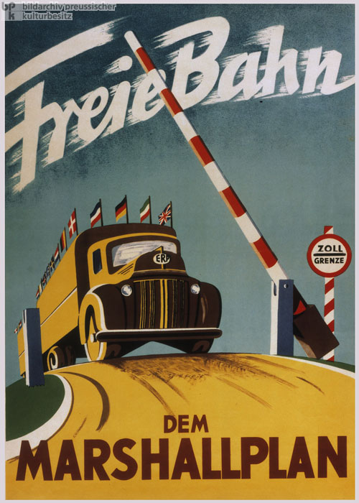
How did Marshall Aid work?

Marshall Aid was an attempt to rebuild Europe after the Second World War. It put the ideas of the Truman Doctrine into effect and together the two were called ‘two halves of the same walnut’ by Truman. In March 1947 President Harry Truman offered grants of American money to all European countries. The plan was named after his Secretary of State George C Marshall who had visited Europe and seen the devastation caused by the war.

Truman had also been shocked by the damage caused when he visited Europe for the Potsdam Conference. He had also served as a captain in the US army in Europe in 1918 and wanted to help Europe recover from the effects of a second world war.

The USA intended to offer Marshall Aid to all countries in Europe. This would mean that the USA would be able to influence the countries of the east and undermine communism. This was what Truman had hoped would happen. The USSR and other eastern countries did attend the first meetings in 1948, but withdrew when they discovered that they would have to join the Organisation for European Economic Co-operation, the body which was set up to determine how the money would be divided amongst participants.

When the Soviet Union realised how much influence the USA would have and that the USA would become close trading partners with members of the OEEC. The Eastern Bloc countries were forced to withdraw applications for Marshall Aid. Poland and Czechoslovakia had applied early for Marshall Aid and looked forward to receiving assistance – until Stalin stepped in.

Altogether seventeen countries (Austria, Belgium, Denmark, Eire, France, Great Britain, Greece, Iceland, Italy, Luxembourg, Netherlands, Norway, Portugal, Sweden, Switzerland, Turkey and the West’s zones in Germany) received a total of $13,750,000,000, which allowed them to recover from the war much more quickly than the countries of the east. Italy, which had been an ally of Germany during the war, received $600,000,000.

Marshall Aid was one of the reasons why Stalin tried to force the west out of West Berlin in 1948.

How did the Soviet Union react to the Truman Doctrine and the Marshall Plan?

COMINFORM (Communist Information Bureau)

This was established in September 1947. It emerged from a meeting about whether to attend US meetings about the Marshall Plan. Its purpose was to co-ordinate the activities of Communist Parties in the world not only in Soviet dominated countries. For Stalin, COMINFORM was a way of spreading his anti-American and anti-British views to communist parties across not only his satellite states, but the world.

Essentially, COMINFORM was to indicate how Stalin’s foreign policies were to be followed. One of the first messages Stalin put across was that the Marshall Plan was a US policy to enslave European states. Stalin insisted that any Communist state or Party which did not follow the Moscow party-line would be expelled from the organisation.

COMECON (The Council for Mutual Economic Assistance)

Naturally, Stalin, in denying Eastern Europe access to the Marshall Aid, had to create his own economic rescue plan to communist countries in order to help them recover from the effects of the Second World War. He thus set up a Soviet version of Marshall Aid, COMECON, the Council for Mutual Economic Assistance, on January 25 1949. The founding members were The Soviet Union, Hungary, Czechoslovakia, Bulgaria, Romania and Poland. East Germany joined in 1950.

The Soviet Union wanted each member to develop its own specialisms – e.g. Romania on agriculture and Czechoslovakia on industry. However, this was not always successful, and some member states objected to the Soviet Union forcing specialisms on them. They especially hated the price fixing which favoured the Soviet Union. COMECON eventually became a major drain on the resources of the Soviet Union and helped to bring about its economic downfall in the 1980s.

Checkpoint: Marshall Aid

Why did Truman offer Marshall Aid? Why did Stalin refuse it?

Truman | Stalin

The development of the Cold War, 1948-49

How was Germany governed after the war?

The agreements at Potsdam about Germany’s future eventually caused the major rift between the wartime allies.

At Potsdam it had been agreed that Germany would be divided into four zones, one each for the USA, the USSR, Britain and France. Each of the four allies was to be responsible for its own sector. Decisions affecting Germany as a whole would be taken jointly and it was intended that Germany would be reunited in the future. But the key agreement was that all decisions had to be agreed by the four occupying nations. Berlin the capital of Germany was inside the Soviet Zone, and this was also divided into four sectors. It was governed by the Joint Kommandatura, which contained the military leaders of the four allies.

The Berlin Blockade, 1948-49

The Berlin Blockade lasted from June 1948 until May 1949. In June 1948, Joseph Stalin ordered that all traffic between West Germany and West Berlin should be stopped. He closed all the road, canal and rail routes, but was not able to prevent the western allies, Great Britain, France and the USA from bringing supplies into West Berlin by air. This was the Berlin Airlift.

Why did Stalin blockade Berlin?

The main reason for the blockade was that Great Britain and the USA had made it clear that they intended to rebuild the economy in their zones of Germany. In January 1947, the British and US zones were joined together in ‘Bizonia’. Stalin said this broke the Potsdam agreements. Moreover, he did not like the prospect of parts of Germany recovering economically – his aim still remained - to keep Germany weak. Bizonia would assist in the future economic recovery. His fears increased in April 1948, when the French zone was added to create ‘Trizonia’. Once more Stalin said that this broke the Potsdam agreements.

Tension continued to increase. Shortly after the creation of Trizonia, the Western Allies announced that they were going to introduce a new currency, the Deutschmark, to help the economy get going again. Stalin yet again said the new currency broke the Potsdam agreements. The Western Allies said the new currency was introduced to prevent inflation and to stop the black market trade and bartering which were still common three years after the end of the war. The new currency would mean that the eastern and western parts of Germany would now be separate economically and would begin to develop at different rates. This angered Stalin and the Soviet authorities. Furthermore, Stalin saw that West Berlin was a temptation to East Berliners. In the west, the Marshall Plan was beginning to make life much better and already East Berliners and East Germans were trying to escape to the west.

For more information on the Berlin Blockade, click here

Checkpoint: Western and Soviet aims in Germany

How did the aims of the West and Stalin differ over Germany?

West | Stalin

How did the Allies react to the Blockade?

The Western Allies were determined that Stalin should not succeed in his plans to blockade West Berlin. General Lucius Clay, the US commander in Berlin said, ‘If West Berlin falls, West Germany will be next’. This seemed to accord with the US view of communism; that once it had a foothold in an area it would spread like in on blotting paper. The Allies believed that if they gave in Stalin would behave as Hitler had in the 1930s, then more and more countries would be taken over.
Clay offered to fight his way out of West Berlin, but was ordered not to by Truman. The USA had reduced its army after the war and, by 1948, it had only about 500,000 soldiers.

The solution was to fly supplies to the two million citizens of West Berlin. The U.S. action gave the name Operation Vittles and the British gave the name name Operation Plainfare to the airlift.The Airlift began on 28 June 1948.The Allies began to bring supplies into West Berlin by air. 4,000 tonnes were needed every day. Eventually they were bringing in 8,000 tonnes; even coal was brought in by plane.
The airlift reached its peak on 16–17 April 1949 when almost 1400 flights landed nearly 13,000 tons of supplies in 24 hours. On 12 May 1949, Stalin called off the blockade. He had failed to starve the Allies out of Berlin.

Map showing the Allied flight routes to West Berlin during the Airlift.

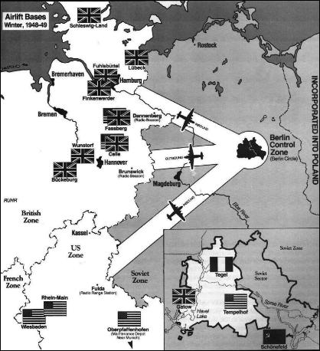

During the Airlift, more than 320,000 flights were made. Success came with a price, 79 pilots and aircrew were killed as a result of accidents during the Operation.

British cartoon, 1948, about the Berlin Airlift.

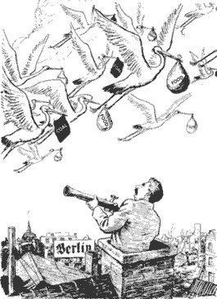
.For more information about the Airlift, click here

What were the consequences of the Berlin Blockade?

The distrust that had been growing between the USA and USSR was now clear for the world to see. It was a sign that relations between the Superpowers were now so bad that some form of military alliance was necessary. The Cold War had started in earnest. The North Atlantic Treaty Organisation (NATO) was set up in April 1949. During the Berlin Blockade, the USA had become concerned about the military power of the USSR in Europe and set up its own military alliance to counter the threat. Member states were – USA, Great Britain, France, Canada, Netherlands, Belgium, Luxembourg, Iceland, Norway, Denmark, Italy and Portugal. The members of NATO made it clear that any attack on any part of their territories would be considered an attack on the whole alliance. NATO led to US troops and aircraft being stationed in European countries to protect them against a possible attack by the countries of Eastern Europe.

Not only did the Blockade lead to the formation of the military alliance which showed once and for all that the wartime alliance was over. The division between East and West was further confirmed when many East German and East Berlin citizens began to try to escape the Soviet zone and move to the West. Above all, 1949 saw the creation in May of the Federal Republic of Germany (West Germany) and the German Democratic Republic (East Germany) in October.

A map showing the division of Germany in 1949

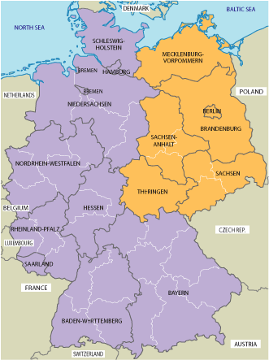

How did the Cold War develop in the period 1949 to 1956?

Communism in Asia

US fears about the spread of communism were realised in 1949 when the Chinese Communist Party, led by Mao Zedong, defeated the Nationalists and established a communist government in China. The USA had been keen to contain the spread of communism in Europe; however, the spread of communism into Asia saw the development of what became known as the ‘domino theory’. This was the belief that if one nation fell to communism then it would be followed by many others; the image of a set of dominoes being knocked over one after the other terrified the USA.

The domino theory seemed to be confirmed by the Korean War, 1950–53. North Korea was ruled by communist forces, supported by the Soviet Union and China. South Korea had a US-supported democratic government. When North Korean forces invaded South Korea in 1950, the USA saw this as the beginning of communist domination of the whole of Asia. This led to US forces being sent to help South Korea against the invading communist forces. President Truman was able to persuade the United Nations to send forces to help South Korea. At the time, the Soviet Union was boycotting the UN and therefore was unable to block the USA’s proposal. The USA sent about 250.000 soldiers and the UN sent almost 40,000 (comprised from 15 separate nations). After three years a truce was signed and Korea remained divided in two – as it had been in 1950.

A map showing the events of the Korean War

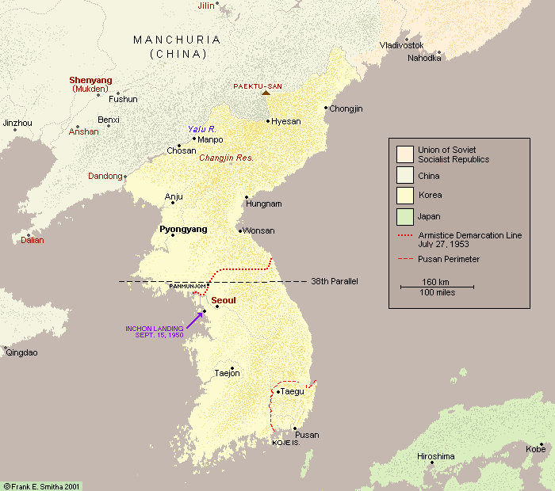
For more information about the Korean War, click here

The beginnings of the arms race

During the Second World War, the USA developed the atomic bomb and used it on two occasions in 1945, at Hiroshima and Nagasaki. Possession of this devastating weapon gave the USA a clear advantage over the Soviet Union and Stalin pushed for the development of the Soviet bomb immediately he was aware of US technological advances. The Soviet Union exploded its first atomic bomb in 1949. This led to an Arms Race between the Superpowers.

Now that both Superpowers owned atomic weapons, each sought to have more than the other. More importantly, each wanted to develop more destructive weapons and huge amounts of money was spent developing these weapons of mass destruction. Furthermore, each Superpower had increased the number of land-based troops in Europe after 1947. Further advances in weapons technology saw the USA test its first hydrogen bomb in 1952 and the Soviet Union test its first hydrogen bomb during the following year.

The death of Stalin

In March 1953 Joseph Stalin died and was eventually replaced by Nikita Khrushchev. Khrushchev believed in co-existence. Rather than try to destroy the West, the Soviet Union should accept that it had a right to exist. However, the USA had elected a new President in 1952, Eisenhower and his chief adviser, Dulles put forward the idea of brinkmanship. Brinkmanship was the gradual escalation of threats in order to achieve the US’s aims. Though he put forward co-existence, Khrushchev still followed Stalin’s policy over West Germany; he still saw it as a threat and still wanted to drive the Allies out of West Berlin. In 1955 Khrushchev set up the Warsaw Pact.

What was the WARSAW PACT?

The Warsaw Pact was set up in 1955 in response to the admission of West Germany (the German Federal Republic) to NATO. This seemed to confirm to Khrushchev that West Germany was becoming a distinct military threat to the Soviet Union. The fear of invasion was never far from the minds of Soviet leaders and this time, as a member of NATO, West Germany had several allies.

The Warsaw Pact was a military alliance of the Communist countries of Eastern Europe. It was the communist equivalent of NATO. The full title was the 'Pact of Mutual Assistance and Unified Command'. It was an attempt to protect the USSR by drawing the countries of Eastern Europe even closer together. The members of the Pact were the Soviet Union, Poland, Hungary, Czechoslovakia, Romania, Bulgaria, Albania and East Germany.

The Warsaw Pact had three important features:

- It created a joint command of the armed forces of the alliance.
- It set up a Political Committee to co-ordinate the foreign policies of the members.
- It bound its signatories to come to the aid of the others, should any one of them be the victim of foreign aggression. This was no different to NATO.

Map showing NATO and Warsaw Pact countries
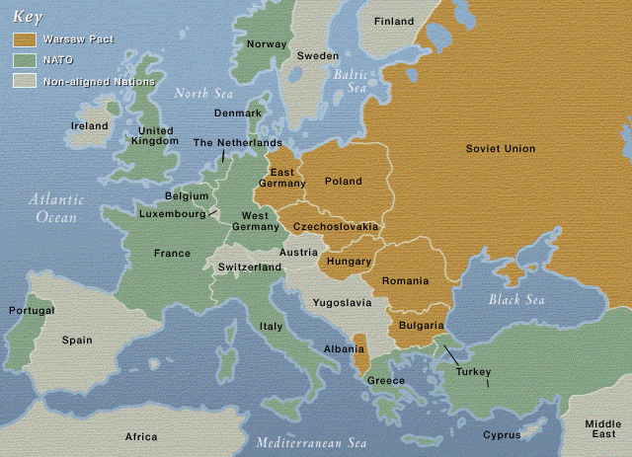

The Pact increased the influence of the Soviet Union in Eastern Europe and led to more Soviet troops being stationed there. Although it was stressed by all signatories that the Warsaw Treaty was based on total equality of each nation and mutual non-interference in one another's internal affairs, the Pact quickly became a powerful political tool for the Soviet Union to hold sway over its allies and harness the powers of their combined military. This made the crushing of the Hungarian Rising of 1956 all the easier. Moreover, its forces outnumbered those of the West and an invasion through northern Germany always seemed very likely.

The West took the threat from the Warsaw Pact extremely seriously until its demise in 1991. Eventually, support for the Pact was financially ruinous for the Soviet Union and was an important factor in the bankruptcy and collapse of the Soviet Union in 1991.

Hungary: the tightening of Soviet control in Eastern Europe

In 1956, there was a serious threat to Soviet control of one of its satellite states – Hungary. The threat was only removed only after Soviet troops invaded Hungary.

Problems began for the Soviet Union in Poland in 1956 after Khrushchev had made his ‘Secret Speech’, in which he criticised Stalin. Rioting, which led to more than 100 deaths, broke out in June 1956, but the real trouble began in October when the rioters were put on trial. Khrushchev was unsure whether to use force or make a compromise. He decided to allow Gomulka to take power and removed some unpopular Stalinists from the government, but Gomulka had to promise that Poland would remain a loyal member of the Warsaw Pact, and the Communist Party remained firmly in control. Much more serious were events in HUNGARY later in the year.

What happened in Hungary?

The impact of Soviet rule on Hungary

Hungary had been an ally of Germany in the war and had fought against the Soviet Union and when Soviet forces went into Hungary, it was as an enemy, not a liberator. In 1945, Hungary’s new Provisional Government agreed to pay the Soviet Union reparations of $300 million and this set the tone of relations between the two countries. The Soviet Union was always harsh in its treatment of Hungary.

Following the November 1945 elections, the leader of the Soviet forces, Voroshilov, ensured that the Hungarian Communist Party became part of the coalition government. Laszlo Rajk, of the Hungarian Communist Party, was put in charge of the security police. Following the elections in 1947, the Hungarian Communist Party took complete control and established a one-party state. The new leader was Matyas Rakosi. Rakosi followed Stalin’s ideas and set up a communist dictatorship and joined COMINFORM (see above).

Hungary under Rakosi

The economy

Hungary was not allowed to receive any Marshall Aid and joined COMECON (see above). The Soviet Union interfered in its economy. Trade was never on a fair basis and exports to the Soviet Union were always below the market price and this created much resentment within Hungary. There was forced collectivisation which was hated by the bulk of the Hungarian population. Moreover, the resentment led to a fall in agricultural output fell as farm workers failed to embrace the changes. In addition, progress in industry was slow and brought little prosperity.

Political and social control

Rakosi followed Stalin’s methods of imposing control on the people which meant that there was a secret police and that control was brutal and universal. The secret police – AVH (Allamvedelmi Hatosag) – was Rakosi’s main means of control and became a feared body. More than 2,000 opponents were murdered during his purges and an estimated 200,000 opponents were imprisoned. It has been estimated that a further 150,000 were removed from their jobs.

Rakosi controlled communications and the media. A further means of control was the attack on the Roman Catholic Church. Religious education was not permitted in schools and in 1949, Cardinal Mindszenty, the leader of the Hungarian Catholic Church, was imprisoned for life in 1949. Mindszenty had been an outspoken opponent of Rakosi’s regime and also of the Soviet Union’s continued interference in Hungary.

Rakosi had difficulty managing the economy and the people of Hungary saw living standards fall. His government became increasingly unpopular. When Joseph Stalin died in 1953, Rakosi was replaced by Imre Nagy who put forward his ideas which were known as the ‘New Course’. Nagy brought in a more liberal regime and promised to improve the economy and increase the production of consumer goods.
However, the Soviet Union disliked his policies and he was sacked in April 1955.

Matyas Rakosi Imre Nagy addressing the Hungarian people on 28th October 1956

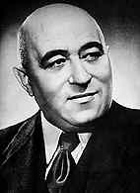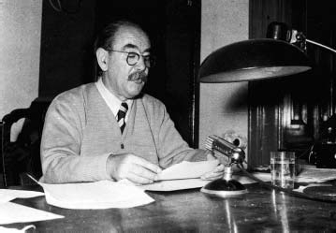

The Uprising

In October 1956 there were student demonstrations in Budapest which led to fighting between Hungarians and Soviet troops. The students demanded an end to Soviet occupation and the introduction of ‘true socialism’. Further demonstration took place the next day and the slogans heard across Budapest included – ‘Russians go home’ and ‘Long Live Nagy’.

On 24 October Imre Nagy became prime minister of Hungary once again. Nagy set up a new government, which included non-communists. .John Foster Dulles, the US Secretary of State, told Nagy - ‘You can count on us’. Nagy saw this as a firm commitment from the USA. However, there was fighting between Hungarian and Soviet troops. Khrushchev tried to deal with the situation by withdrawing the Soviet troops from Hungary.

Photograph of a statue of Stalin, destroyed in Budapest during the Uprising
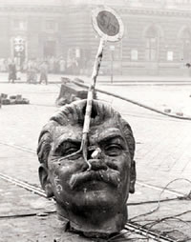
On 30 October, Nagy announced there would be free elections in Hungary. Cardinal Mindszenty and other leading political prisoners were released. The situation was then exacerbated on 2 November, when Nagy declared his intention that Hungary would withdraw from the Warsaw Pact. Khrushchev looked on in horror as he saw one of his satellite states about to create a hole in Eastern Europe and weaken the Warsaw Pact.

Khrushchev decided to act and on 4 November he ordered the Soviet army to invade Hungary and crush the uprising. 200,000 Soviet troops and 6000 tanks returned to Hungary. There was bitter street fighting; 7,000 Soviet troops and 4,000 Hungarians were killed. (At the time, it was stated by Western observers that about 30,000 Hungarians had been killed.) A ceasefire was agreed for 10 November but some fighting continued into the next year. Nagy was arrested and executed in 1958.

Britain and France did not become involved because they were distracted by their involvement in the Suez Crisis, and the USA offered no assistance. For these three, the Suez Crisis seemed more important.

For more information on the Hungarian Uprising, click here

For photographs of the Hungarian Uprising, click here

What were the results of the uprising?

Khrushchev was able to keep control of Hungary and a new Soviet-backed leader, Kadar, was installed. Kadar remained leader until 1965. However, about 200,000 Hungarians escaped to Austria during the uprising showing the world that they preferred exile than live under a communist regime. Large numbers of Hungarians were put on trial and imprisoned. Some were sent to the Soviet Union. Cardinal Mindszenty was granted political asylum at the United States embassy, where he lived for fifteen years before being permitted to go to Austria.

For Khrushchev, the Uprising had been a great success. He showed that Soviet satellite states had to comply with the wishes of Moscow or suffer the consequences. Despite the talk of co-existence, Khrushchev showed the uncompromising nature of the Soviet Union. But above all, he had kept the Warsaw Pact intact.

President Eisenhower and the USA had shown that they were not prepared to go to war. Furthermore, the United Nations was unable to become involved because the Soviet Union used its veto in the Security Council.

As a postscript to the Uprising, the Melbourne Olympic Games were boycotted by Spain, the Netherlands and Switzerland as a protest at the Soviet treatment of Hungary. Several members of the Hungarian Olympic team defected after the games.

Checkpoint: The Hungarian Uprising

Why did the Hungarians want to break away from Soviet control? Why was Khrushchev determined to prevent them?

Hungarians | Khrushchev

